|  |  |
| --- | --- |
| **Name**: Yao Yuheng | **Title**: Explore the Population Change of China |

1. **Objectives**

The objectives were to illustrate the reasons behind China's slowing population growth. There are two aspects of analysis: marriage and fertility, which can possibly explain the reducing of population growth. We also decompose the problems into more detailed one, for example, age structure, first marriage age, housing price and, childcare cost.

1. **Novelty**

There are mainly two novel contribution of the visualisation. First is the thinking flow of the project. Although there are existing data analyzing the marriage, housing price, childcare and so on, we introduce chain of reasoning to analyze the reasons behind the change of population and use these data to support the analysis. The second innovation is that we integrate the data of population growth, first marriage, housing price and fertility rate and build a regression model to verify the relationship of the variables.

1. **Technical Challenges and Innovation**

**Dynamic heat map of world population:** with the data of world population from 1949 to 2023, we draw the picture of global heat map with geopandas for every year. Then we use animation in Matplotlib to create a gif with all the pictures.

**Interactive visualisation:** the picture of population of China and population growth are interactive made by plotly, which allows us to see the detail of a particular year.

**Various chart types with customized content:** we create multiple charts to convey the information, including bidirectional column chart, bar charts with colored filling, line charts with closure and annotation, pie chart, scatter plot, and bubble chart. These charts need massive coding and adjustments.

1. **References**

List the main reference sources that have contributed preliminary ideas and technical help during design and implementation of the project. The source and weblink where the datasets were taken from should be listed at the start of your list of references.

1. HYDE (2023); Gapminder (2022); UN WPP (2024) – with major processing by Our World in Data
2. China National Bureau of Statistics. (2023). China Statistical Yearbook 2023. Retrieved from [https://www.stats.gov.cn/sj/ndsj/2023/indexch.htm](https://www.stats.gov.cn/sj/ndsj/2023/indexch.htm" \t "_new)
3. Hannah Ritchie, Lucas Rodés-Guirao, Edouard Mathieu, Marcel Gerber, Esteban Ortiz-Ospina, Joe Hasell, and Max Roser (2023). "Population Growth" published at OurWorldinData.org.
4. Max Roser (2014). "Fertility Rate" published online at OurWorldinData.org.
5. He, D., Zhang, X., Zhuang, Y., Wang, Z., & Yang, S. (2018). China Fertility Status Report, 2006-2016: An Analysis Based on 2017 China Fertility Survey. Population Research, 42(6), 35-45.
6. Liang, J., Ren, Z., Huang, W., He, Y., & Yu, J. (2023). China Marriage and Family Report 2023 Edition. Yuwa Population Research, August 2023.
7. E-house Research Institute. (2022). 2021 National House Price to Income Ratio Report. E-house Research Series.
8. Liang, J., Huang, W., & He, Y. (2024). China Fertility Cost Report 2024 Edition. Yuwa Expert Team, February 2024.
9. China National Development and Strategy Institute, Renmin University of China, Urban Renewal Research Center. (2022). Housing Report 2022: Insights from China’s Seventh Census on Urban Housing Development.

**Figures and Tables**

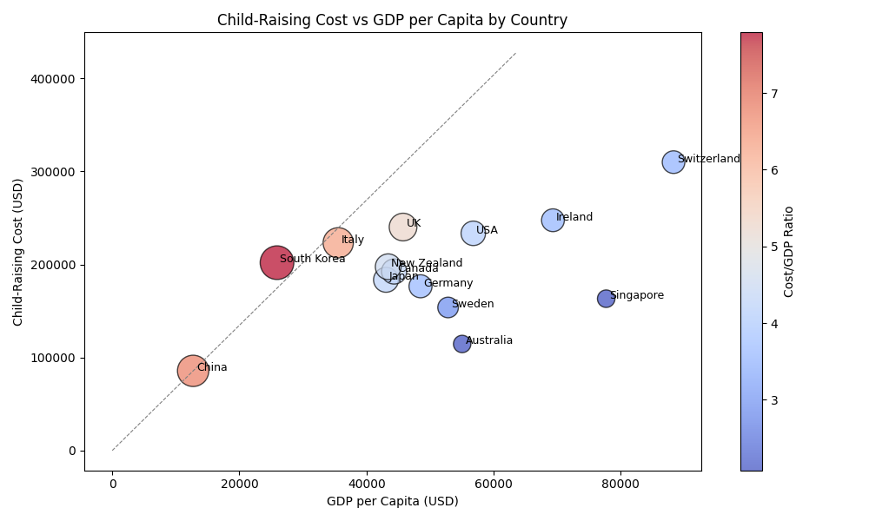

Bubble chart Dynamic heat map of world population

Pie chart Colored bar chart

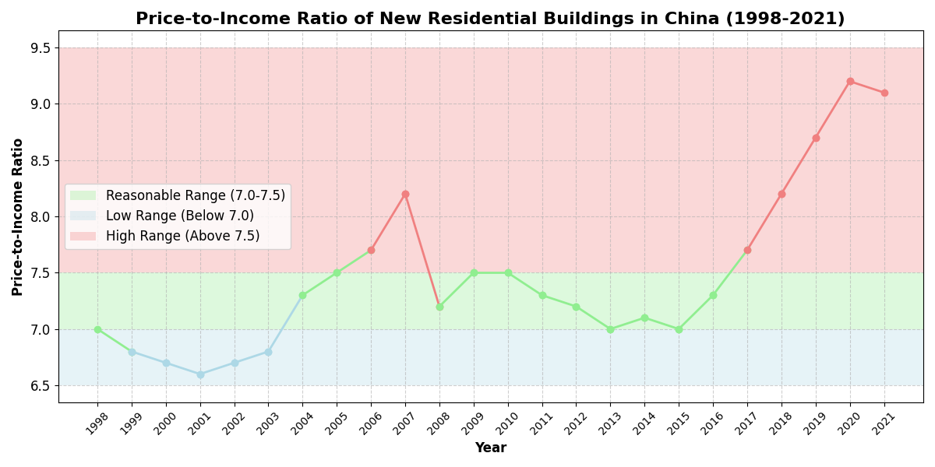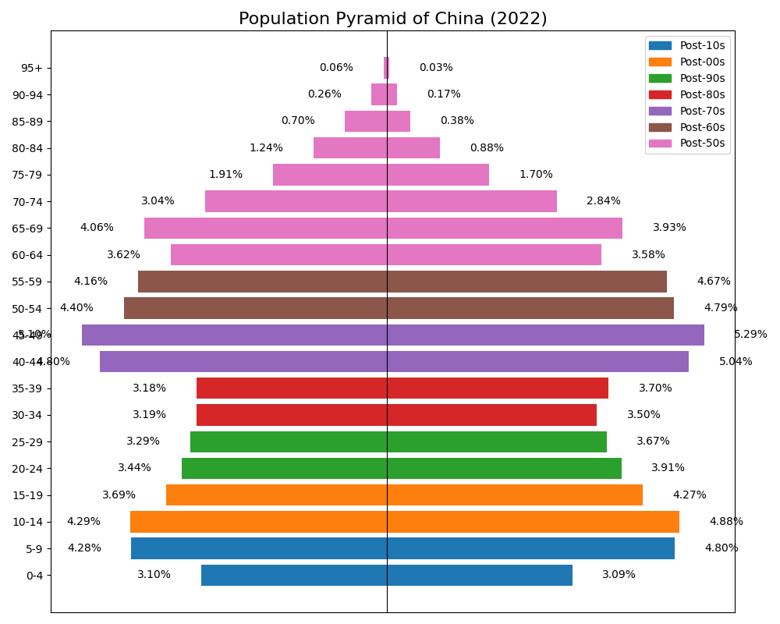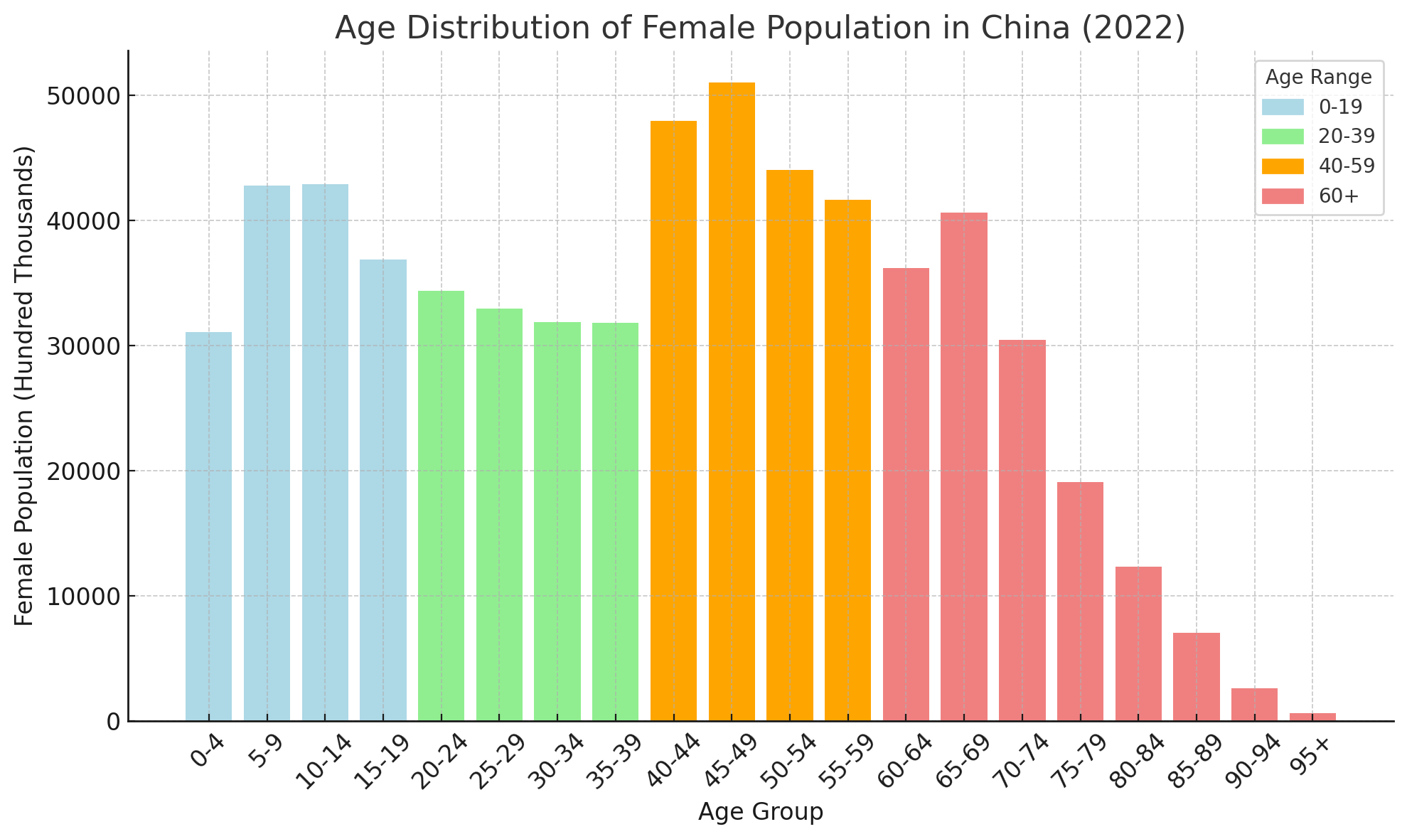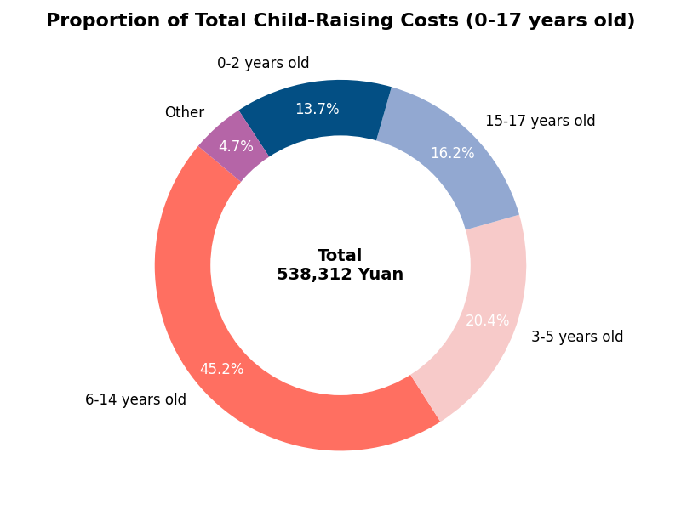

bidirectional column chart line chart with colored filling